Portuguese Control of the Indian Ocean Trade during the First Global Era (1450 – 1770 CE)

Author: Allyson McCarthy

Overview and Purpose of the Lesson:
Although many world powers such as Great Britain and France were present in Indian Ocean trade throughout the first global era, few powers seemed to dominate that trade over that time. The dominant powers of the period were the Portuguese and later the Dutch. However, prior to any European rule controlling the trade routes in the Indian Ocean, Arab merchants sailed effortlessly throughout the region profiting off of the abundant resources including porcelain, silk, silver, spices, and more. This Arab domination of the trade routes would drastically change after the voyage of the Portuguese explorer Vasco de Gama who set out from Portugal to reach the Indian Ocean by sea. Throughout this lesson, students will discover why the Portuguese sent Vasco de Gama on his voyage and how his voyage affected world trade. Students will also learn about some of the cities that the Portuguese commandeered in their efforts to dominate Indian Ocean trade.
In Part I of this lesson, students will become acquainted with the geography of the Indian Ocean and commonly traded items and their originating location by exploring the Goods icons on the First Global Era map on the Indian Ocean in World History (IOWH) Website. Students will then fill out Handout A using the information they gathered. In Part II, students will work individually to learn more about Vasco de Gama and map out his voyage from Portugal to India. They will do this by reading excerpt A, filling out Handout B and continue filling out handout A with the help of an Atlas. In Part III, students will work in pairs or in groups to discover cities and regions in the Indian Ocean that were attacked or influenced by the Portuguese by exploring the Places icons on the First Global Era Map on the IOWH Website. The students will then fill out Handout C using the information they gathered from the website. Finally, students will reconvene and share the information they gathered about their different cities and discuss the impact the Portuguese had on the Indian Ocean throughout the First Global Era.
Performance Objectives.
- To understand what goods were commonly traded throughout the First Global Era in the Indian Ocean and where they originated
- To understand how the Portuguese dominated the Indian Ocean Trade
- To assess the impact of the Portuguese on the Indian Ocean
Materials Needed:
- Access to the IOWH Website
- Handouts and readings included in the lesson (one of each for each student)
- Atlases
- At least 3 different colored pencils/markers for each student (i.e. Blue, Red, Green)
Time: Roughly three class periods total, one class period for each part

1

Procedure:
Introduction and Context
Introduce students to the Indian Ocean, the third largest ocean in the world after the Atlantic Ocean and Pacific Ocean (the world’s largest). By clicking on the geographical icons for Travelers, Places and Goods on the First Global Era Map students can learn more about the history and movement of peoples throughout the era.
Tell students that they are going to learn about trade and conquest on the Indian Ocean during the First Global Era (1450-1770 CE) focused on Portugal. During this time, European Powers began exploring more efficient and cost effective ways to trade goods to and from the East, especially in regards to hubs in the Indian Ocean.
Part I:
In order to help students get the “big picture” of the geography of the Indian Ocean, project the First Global Era map from the IOWH Website such that the whole class can see it at one time. If this is not possible, assign students to look at it individually (in a computer lab or at home, etc.) and reconvene to share answers.
From their observations, you will want the students to see silver and porcelain from China; spices from Indonesia and the Philippines; cloth, opium, and ebony from India; gold, ivory and copper from Southeast Africa; vanilla from Madagascar; and coffee from Yemen. The students should also discover that Europeans traded for these goods with many western items or traded for these goods with goods they had previously traded, therefore globalizing all sorts of merchandises.
Questions to pose as students look at the map:
- Where do most of the icons appear? Why do they think this is?
- Look at the solid orange lines, which represent water trade routes. What are the busiest areas of trade on the Indian Ocean? Which areas form the hubs of trade, the locations from which goods and people are going in and coming out?
- Now begin selecting the “goods” icons. Where do we find cloth? Silver? Spices? Etc. Were these items traded to be in these locations, or are they cultivated there? Discuss each item in depth and give them time to map these goods onto handout A with a blue pencil.
Part II:
Tell students they are going to look more closely at Portugal’s role in trade in the Indian Ocean by learning about Vasco de Gama’s voyage.
- Have the students watch this brief clip from CBS News titled How Portugal Became the First Global Sea Power until 5:10, or all the way through (8:38). http://www.cbsnews.com/news/how-portugal-became-the-first-global-sea-power/

2

- Then tell them to work individually and read through Excerpt A from bbc.co.uk which describes who Vasco de Gama is and why he is important.
- With the help of an Atlas, have the students use the information from the excerpt to map out his voyage beginning in Lisbon and ending in India on handout A with a red pencil. Have them first plot the places, then later add the line connecting the dots showing the water route he took to get to India. Include place names and dates in which he arrived when included. Use partners or small groups if there is a limited number of atlases.
- Have the students reconvene and discuss the following questions (with the optional
handout B)
  - How long did it take Vasco de Gama to reach India from Portugal?
  - Why did Portugal send Vasco de Gama to India?
  - Why did he go all around the tip of Africa? Why not through the Mediterranean sea then through the Red sea?
  - What did his voyage do for trading in the Indian Ocean? Not just for Portugal.

Part III:
If possible, have the students do number 1 and 2 of this activity on their own either in lab or as homework. However, it may also be done as a class.
- Have the students click on all of the “Places” icons on the First Global Era Map on the IOWH Website and have them fill out Handout C. Not all the spaces need to be filled out, not all the places on the map will have information for every block on the chart.
- Then have the students return to Handout A and with the help of an atlas, only map the cities that Portugal conquered with a green pencil.
- Have the students reconvene and discuss the following questions:
  - In what country are most of Portugal’s hub cities? Why do you think that?
  - How are these hub locations significant? In regards to the different commonly traded goods already on handout A?
  - What is so significant about Portugal controlling the Strait of Hormuz and the Strait of Malaca?
  - What important things did Portugal bring to the region? Religion, trade items, etc. and how were they received?
  - How else did Portugal effect the development of trade and cities in the Indian Ocean region?

Assessment:
- It may be decided to have the students hand in their maps (handout A) in order to check for completion
- Have the students turn in handouts B and C for further assessment.
- Assign an brief research essay asking students to delve more into a specific way that Portugal has effected the Indian Ocean with this prompt:

3

How has Portugal effected the Indian Ocean in trade routes, trade methods, religion, or a specific region or city? Pick one way Portugal has changed the Indian Ocean and expand upon it with information from class handouts and activities, the IOWH Website, or other reliable sources.
- Or have a quiz using the questions from handout B and the following questions:
  - What is significant about Portugal Controlling the Strait of Hormuz and the strait of Malaca?
  - In what regions did Portugal have hub cities?
  - What major effort did Portugal bring to the Indian Ocean?

4

Vasco de Gama By Shane Winser
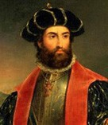
Vasco da Gama was the first European to open a sea-based trade route to India. In an epic voyage, he sailed around Africa's Cape of Good Hope and succeeded in breaking the monopoly of Arab and Venetian spice traders. The Royal Geographical Society's Shane Winser explains how da Gama changed the world.

The search for trade routes

Vasco da Gama's pioneering sea voyage to India is one of the defining moments in the history of exploration. Apart
from being one the greatest pieces of European seamanship of that time - a far greater achievement than Christopher Columbus's crossing of the Atlantic - his journey acted as a catalyst for a series of events that changed the world.

By the middle of the 15th century, Portugal was the leading maritime nation in Europe, thanks largely to the legacy of Prince Henry the Navigator, who had brought together a talented group of mapmakers, geographers, astronomers and navigators at his school of seamanship at Sagres, in southern Portugal.

Henry's intention had been to find a sea route to India that would give Portugal access to the lucrative trade in spices from the Far East. He had hoped to be aided by an alliance with the elusive Prester John, whose Christian empire was thought to exist somewhere in Africa and who might have provided assistance to Christians in any fight to overcome Muslim dominance of the Indian Ocean trade. For 40 years, Henry sponsored voyages of exploration south along the west African coast, resulting in a lucrative trade in slaves and gold - but the southern extent of the continent remained unknown to Europeans, and the Prince's dream was not realised.

It was not until 1487 that Bartholomew Diaz set off on the voyage that finally reached the southern tip of Africa. By rounding the Cape of Good Hope, Diaz proved that the Atlantic and Indian Oceans were not landlocked, as many European geographers of the time thought, and rekindled the idea that a sea route to India might indeed be feasible.

To complement the sea voyages of Diaz, the Portuguese monarch King John II also sent Pedro da Covilha, a fluent Arabic speaker, out on a dangerous overland journey to India. Disguised as an Arab, Covilha gathered vital information on the ports of the east African and Indian coasts during his three-year journey.

It would, however, be a further ten years before the Portuguese were able to organise a voyage to exploit the discoveries of these two explorers. In the meantime, Christopher Columbus, sponsored by the Spanish, had returned to

Europe in 1493 to announce that he had successfully found a route to the Orient by sailing west across the Atlantic.

The first voyage to India

Vasco da Gama and his fleet sailed from Lisbon on 8 July 1497. Bartholomew Diaz himself acted as pilot to the Canary Islands, which they reached on 15 July, and on to the Cape Verde islands. On board were the latest maps and navigational instruments. Between 26 July and 3 August the crew prepared for the next stage of their voyage without Diaz, who advised them to take an unusual course: west- south west in a huge loop out into the Atlantic to avoid the doldrums in the Gulf of Guinea. They were 965km (600 miles) from Brazil before the south-westerly winds blew them back towards southern Africa.

On 7 November they landed at St Helena Bay, 200km (125 miles) north of the Cape of Good Hope. They had been out of sight of land for 13 weeks - much longer than Columbus on his trans-Atlantic voyage - and had travelled a distance of more than 7,200km (4,500 miles) from Cape Verde.

Two days later, after leaving St Helena Bay, they rounded the Cape of Good Hope and landed at Mossel Bay, where they traded trinkets with local people in exchange for an ox. The store ship was burnt, and the supplies re-distributed among the other ships. They would now be sailing in unknown waters, having almost reached the farthest extent of Diaz's explorations.

On Christmas Day 1497 the three remaining ships were sailing northwards along the east coast of what is now South Africa and called the country 'Natal'. By 11 January 1498 they were exploring the mouth of Copper River ('Rio Cobre') (modern location is between South Africa and Mozambique), named after the copper ornaments worn by the local population.

Moving slowly north east against a strong south-westerly current, they travelled 2,700km (1,700 miles) up the coast until, on 2 March 1498, they sailed into the port of Mozambique. This was one of a chain of Muslim city states, at the southernmost point of Muslim influence on the east African coast. When da Gama tried to trade with the ruling Sultan his paltry gifts were scorned. Despite sparing no expense to equip the expedition, the Portuguese had totally underestimated the quality of goods being traded in this part of the world - cotton, ivory, gold and pearls. They sailed on to Mombassa, 1,300km (800 miles) north, in the hope of more lucrative trade, but fared no better there. Fortunately the ruler of Malindi was more welcoming, and during his stay there da Gama recruited a knowledgeable and efficient pilot, possibly the great Arab navigator Ahmed Ibn Majid, to show the explorers the route to India.

Da Gama reaches India

The 27-day crossing of the Arabian sea, via the Laccadive Islands to the Malabar Coast of India, was eased by the favourable monsoon winds, and the fleet arrived at Calicut on 20 May 1498.

India's Malabar Coast was at the centre of the spice trade - it was the main outlet for Kerala's large pepper crop - and the place where ships from the Indonesian Spice Islands came to trade cloves with Arab merchants from the Red Sea and Persian Gulf. The newcomers stayed for three months, and were initially well received by the Hindu ruler, the Zamorin. But the Muslim traders also held considerable influence at court, and were unwilling to relinquish control of the spice trade to the Christian visitors - and once again the goods da Gama was offering to trade were inadequate. Relations deteriorated, and da Gama's men were reduced to bartering on the waterfront to trade what goods they could for the homeward voyage.
It was a terrible voyage back to Malindi. The pilot could not be found, the monsoons were against them and the 3,700km (2,300 mile) journey took three months. Da Gama's crew suffered terribly from scurvy and 30 men died. Only the kindness of the Sultan of Malindi saved the rest of the crew, with his gifts of fresh meat and oranges.
But now, with too few men alive to sail three ships, the St Raphael was burnt. Keen to get home, the adventurers rounded the Cape of Good Hope on 20 March 1499, and sailed up the west coast of Africa. Paolo da Gama, who had been very compassionate to the sick and ailing throughout the voyage, finally succumbed to illness himself, and died on the Azores.

Secondary voyages to India

Vasco da Gama arrived in Lisbon on 18 September and rode in triumph through the city. He had been away for more than two years, travelled 38,600km (24,000 miles) and spent 300 days at sea. Only 54 of the original crew of 170 had survived, but King Manuel was very pleased. What had been done once could be done again.

A second voyage, involving 13 ships and 1,200 men, was immediately dispatched under Pedro Alvares Cabral to secure the sea route to India, and the fleet reached Calicut in under six months. This time the Portuguese were better prepared and brought lavish goods with which to tempt the Zamorin into a trade agreement. The Muslim merchants were outraged at this attempt to steal their trade, and killed 50 of Cabral's men.
Cabral retaliated by burning ten Muslim cargo vessels and killing nearly 600 on board, and setting light to the wooden houses of Calicut in revenge. He then moved on to Cochin, where he established the first Portuguese trading post in India. He returned home in the summer of 1501. Only seven ships and half his men survived the journey, but their cargo of spices was sufficient to break the monopoly on the European spice trade previously held by Arab and Venetian merchants.
The following year, Vasco da Gama commanded Portugal's third major voyage to India. He set out with a fleet of 20 ships, including ten of his own and five each under the command of his uncle and nephew. Their task was to consolidate

Portuguese dominance of the route to India, but it was to lead to one of the worst maritime massacres in history.

After raids on several Muslim ports along the east African coast, da Gama began a campaign of terror against Muslim shipping off the Malabar Coast. Here he captured the Meri, a ship with 200 Muslim pilgrims on the return journey from Mecca, and set it alight. With some 400 men, women and children aboard, da Gama fuelled the fires for four days until all had died. He then moved on to Calicut, where he captured and dismembered 30 fishermen and let their bodies float in with the tide for their families to find.
Feared and hated, he left behind the first European naval force in Asian waters. Upon his return home in September 1503, da Gama was richly rewarded by the Portuguese for his efforts and was eventually appointed Viceroy of India.

Shane, Winser. "Vasco De Gama." BBC News. February 17, 2011. Accessed November 9, 2015. http://www.bbc.co.uk/history/british/tudors/vasco_da_gama_01.shtml

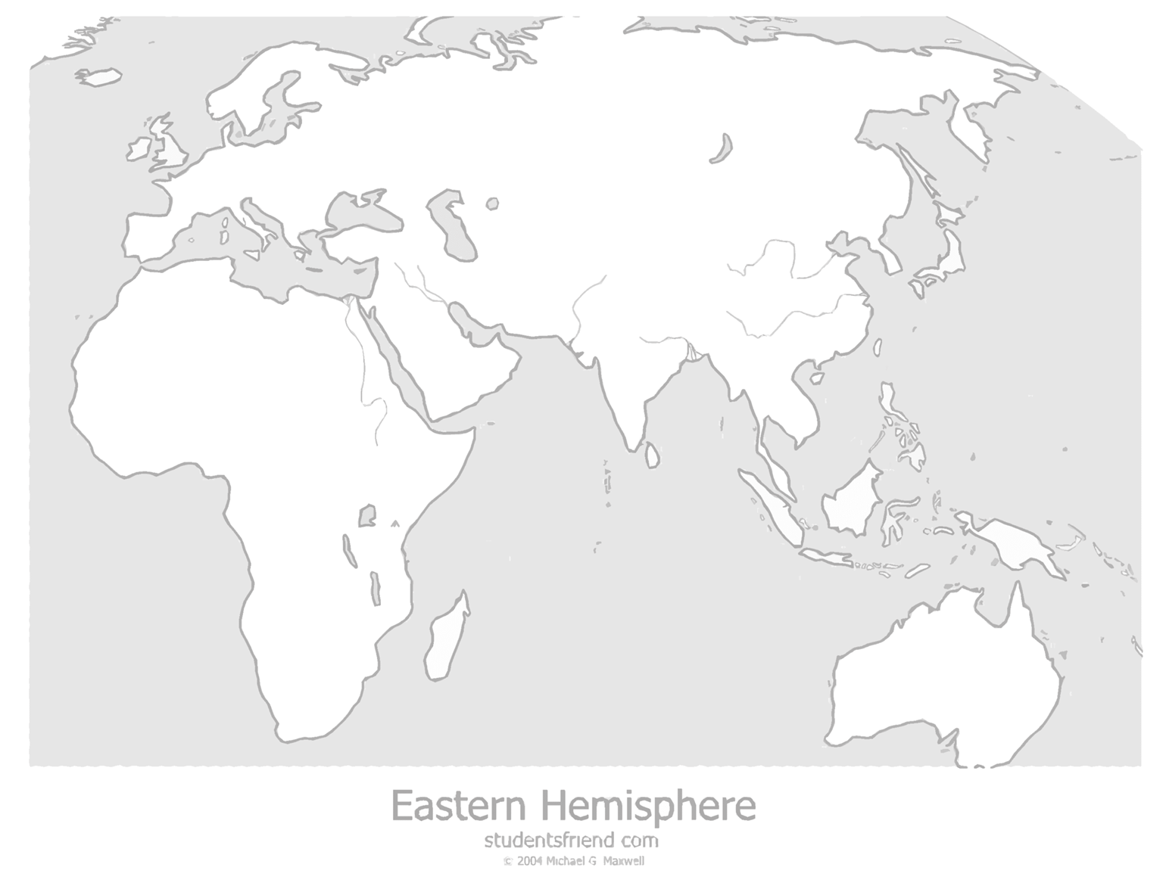
Handout A

Indian Ocean

Portugal in the Indian Ocean Review Questions
- How did Portugal become a global sea power?

- Why did Portugal send Vasco de Gama to India?

- How long did it take Vasco de Gama to reach India from Portugal?

- Why did Vasco de Gama’s route go around Africa past Cape Hope? Why not through the Mediterranean Sea to the Red Sea?

- What did Vasco de Gama’s voyage do for Portugal in regards to trading in the Indian Ocean?

- What did Vasco de Gama’s voyage do for other European powers in regards to trading in the Indian Ocean?

Handout C: IOWH Name
Date

Place Name | Location (Country/continent) | Goods/Exports | Conquered by Portugal? If so, when? | What did Portugal bring to them?
Ex. Kilwa | Southeast Africa | Gold, Ivory, Tortoise Shells | Yes, 1505-1700s | N/A

